Bangia atropurpurea (Mertens ex Roth) C. Agardh 1824
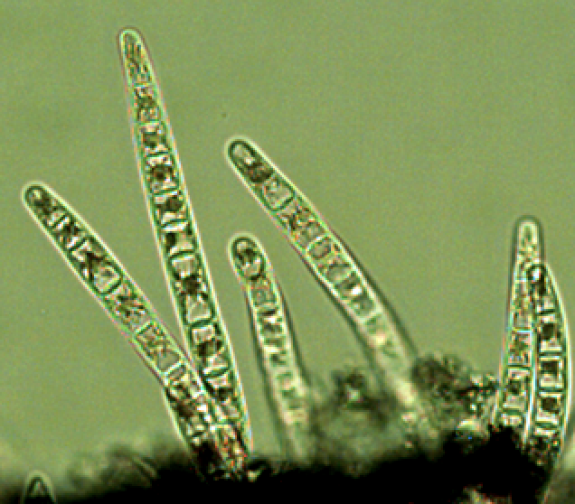

Phylum: Rhodophyta
Class: Bangiophyceae
Order: Bangiales

Habitat: benthos, periphyton
Distinctive features: filaments form dark fur-like fleecy mats at air-water interface in shallow waters (few cm) close to the waterline. The species is found in both marine and fresh waters.
Organization: filamentous (initially uniseriate, later multiseriate)
Color: dark red-brown
Cell shape: cylinder
Cell diameter: ~ 20 μm (but highly variable)
Filament length: Several centimeters

Morphological features: Bangia colonies made of filament aggregation are visible to the naked eye and distinct by their reddish-dark brown to black color (Plate 1). The colonies are attached to surfaces by down-growing rhizoids, usually in dense purple-black to rust-colored clumps. The individual filaments are gelatinous, unbranched. Young filaments are uniseriate (Plate 2), old filaments are multiseriate (Plate 3). A star-shaped chloroplast with a prominent pyrenoid in the center of each cell is typical of the genus. So are cell elongations (Plate 4) occurring from intercalary cells, they are formed as a step in the reproductive cycle (Gargiulo et al. 2001).
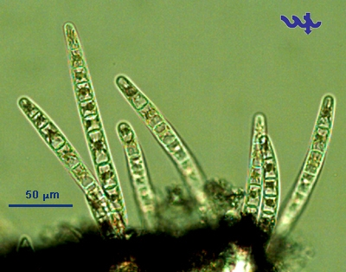
Plate 1. Mat-forming colony of Bangia atropurpurea with young, uniseriate filaments embedded in firm gelatinous matrix.

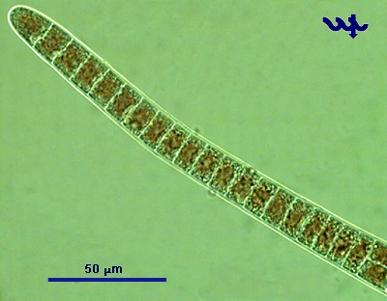
Plate 2. A young uniseriate filament of Bangia atropurpurea showing box shape of individual cells.
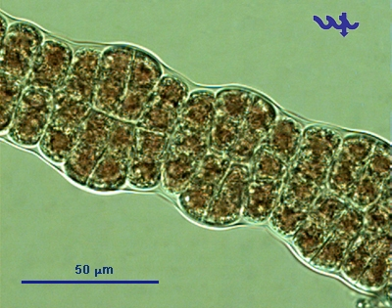
Plate 3. A mature, multiseriate filamenat of Bangia atropurpurea made of cells of different shapes and sizes.
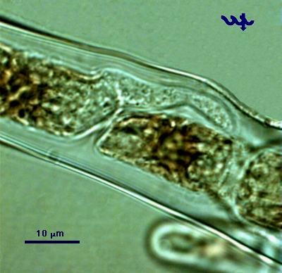
Plate 4. Close up on a uniseriate filament of Bangia atropurpurea showing development of colorless, rizoid-like structure from an intecalary cell.

Ecology: Seasonally occurring as a fleecy mat in the eulittoral zone of Lake Kinneret on near-shore hard surfaces (often concrete) in extremely shallow waters. It appears in December each year, for a few weeks, then disappears, to re-appear in following years. Since it is absent in the pelagial, where samples for our monitoring program are collected, we have no abundance nor size data for it.
Most Rhodophytes are marine. Only ~ 3% of the ca. 5000 species of Rhodophytes occur in freshwaters, Bangia atropurpurea is one of them.
Physiological features: Known as being a highly adaptive species due to its stress tolerance. The same species is found in both marine and freshwater environments. Can survive desiccation and extreme solar radiation (in the supra-littoral zone). The species is an indicator of fresh, clear water.
Further reading:
Gargiulo GM, Genovese G, Morabito M, Culoso F, De Masi F. 2001. Sexual and asexual reproduction in a freshwater population of Bangia atropurpurea (Bangiales, Rhodophyta) from eastern Sicily (Italy). Phycologia, 40: 88–96. https://doi.org/10.2216/i0031-8884-40-1-88.1
Cite this record as:
Tamar Zohary, Alla Alster. 4 May 2026. Electronic publication. Israel Oceanographic & Limnological Research. [Date when last accessed].

